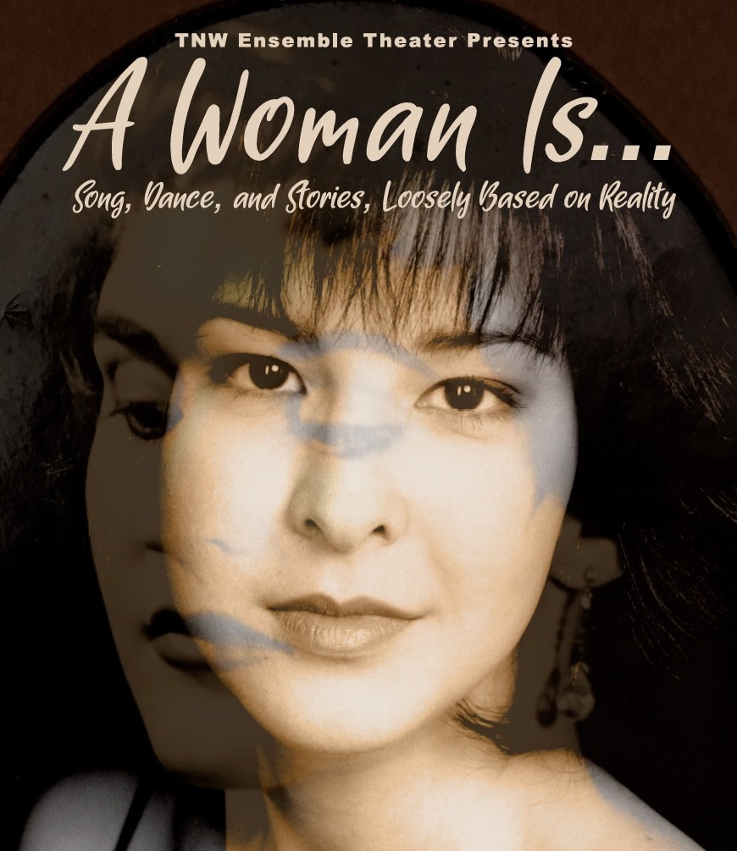

A Woman Is… Press Packet
A Woman Is…
A cabaret about family, identity, and becoming who you are

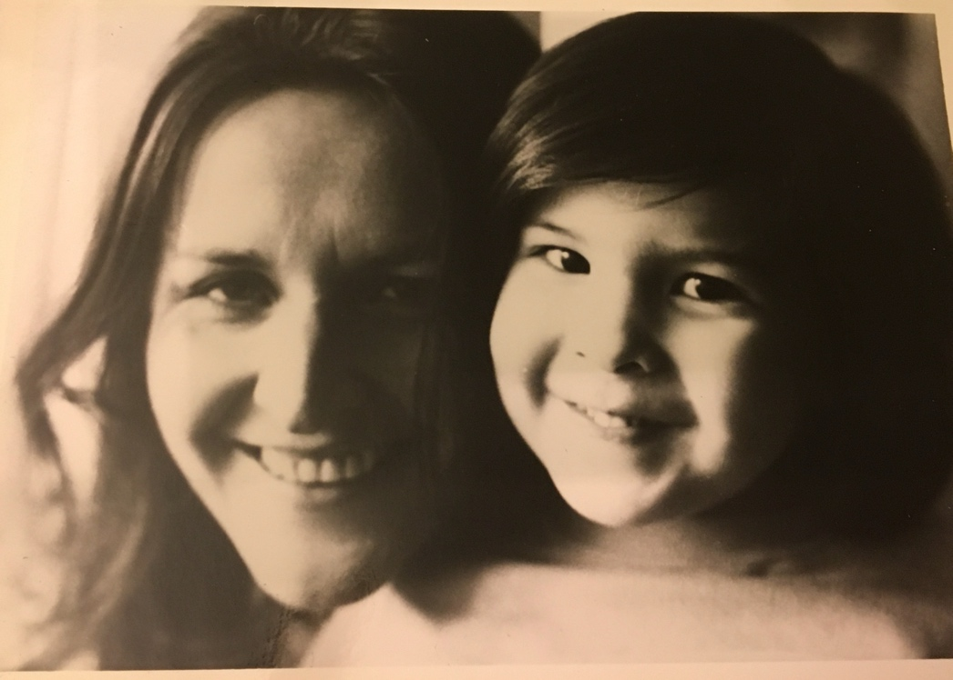

Part monologue, part musical theater, part tribute, part exorcism...

In this production, Kiki Moritsugu explores her relationship with her larger-than-life mother, Canadian actress Jo Hutchings.

A Woman Is . . . illuminates the complexities of the mother-daughter relationship, addressing universal experiences even as it follows the story of one woman.

Kiki’s story is especially interesting because she is of mixed race descent. Her father is Japanese, and her mother was white. Kiki and her mother are/were both performers through and through. This element drives a story that shows how children and parents must face the conflicting motives for connection and independence.

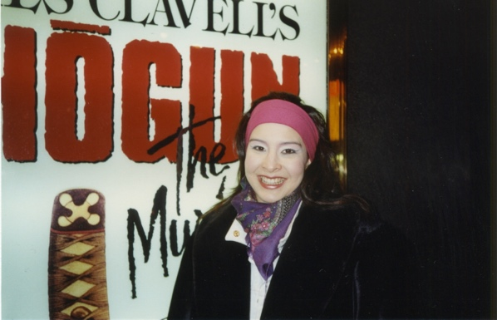
Sharing three generations of backstage stories, Kiki shows the love, laughter, and learning that animated a family where role conflict could be a literal thing…

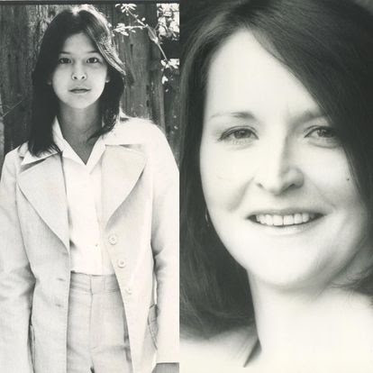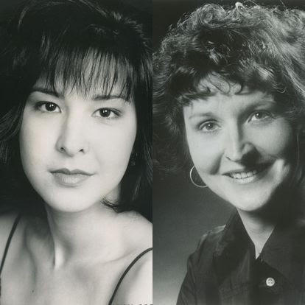
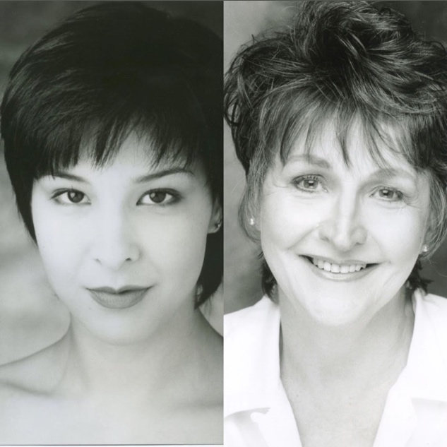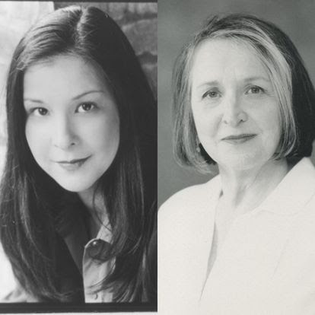

…plus, her own, personal experiences, from summer stock to every shopping mall in Canada to Broadway.

Featured Songs

The Glamorous Life – by Stephen Sondheim, from A Little Night Music

Some Day I’ll Find You – by Noel Coward, from Private Lives

Don’t Put Your Daughter on the Stage, Mrs. Worthington – by Noel Coward

A Little Brains, A Little Talent – by Richard Adler and Jerry Ross, from Damn Yankees

The Boston Beguine – by Sheldon Harnick, from New Faces of 1952

Sayonara – by Hy Gilbert and George Fischoff, from Sayonara

Losing My Mind – by Stephen Sondheim, from Follies

Whatever Lola Wants, Lola Gets – by Richard Adler and Jerry Ross, from Damn Yankees

But Alive – by Charles Strouse, from Applause

Maybe This Time – by John Kander and Fred Ebb, from Cabaret

Bios/Organization Information

Kiki Moritsugu is a dancer, actor, singer, and performer from Toronto. She studied in Canada, performed extensively in NYC, is a musical theater artist, and trained in Japanese martial arts. Kiki Moritsugu appears through arrangement with Actors Equity Association. She is also a member of SAG.

Her career has encompassed theatre, television, film, and music videos, as well as industrial shows, both in Canada and in the United States. She has performed on Broadway (Shogun-The Musical), Off-Broadway (Tokyo Can Can), Off-Off Broadway (Touch), in Toronto (Cats at Massey Hall & 2nd National Tour) and in regional theatres across North America such as the Centaur Theatre (Montreal), The Guthrie Theatre (Minneapolis), Arena Stage, Kennedy Center, National Theatre (Washington, DC), Theatre Under the Stars (Houston & Seattle), and the Huntington Theatre (Boston). Film/TV credits include Delight in the Mountain (Frozen Stage Films), Chicago PD (NBC), The Ethical Slut (Independent), Sing (Tristar).

Recent theatre credits include Sally Bowles in Cabaret (Stage Q/ OUT!Cast Theatre), Wit and Wisdom (TNW Ensemble Theater), Legally Blonde, and Crazy for You (Middleton Players Theatre); Rock of Ages (MTG/OUT!Cast); Falsettos (Stage Q); 42nd St (MPT); Rocky Horror Show (OUT!Cast/Mercury); and Avenue Q (Middleton Players Theatre).

TNW Ensemble Theater, a professional multi-disciplinary performing arts organization, was founded in 1985 by producing artistic directors Donna Peckett and Danielle Dresden. Since then, we have developed, produced, and performed 40 new plays, 15 tap and jazz music performances and 11 works for young audiences, performing throughout the U.S. and abroad. Through short and long-term residencies, we have reached thousands of under-served arts audiences, from older adults to youth from disadvantaged backgrounds. We say we are “driven by the twin engines of artistic innovation and community connection.” We are committed to the pursuit of artistic excellence and dynamic ways to engage the community, especially under-served arts audiences.

Danielle Dresden, author, is co-founder and co-producing artistic director of TNW Ensemble Theater. She has written 39 plays performed across the United States and in Canada, Scotland, and Mexico. Her play, Ben Franklin and Baron von Steuben vs. the Paine County School Board was recently published by Next Stage Press. She was Guest Artist for the Blaine Quarnstrom Playwright Series at the University of Southern Mississippi in 2016 and has been a featured artist at Alaska’s Last Frontier Theater Conference since 2002. She is a member and one of three Ambassadors for Wisconsin for the Dramatists Guild. She serves on the Barrymore Theater Board of Directors in Madison and the Bolz Center for Arts Administration Advisory Board, UW-Madison.

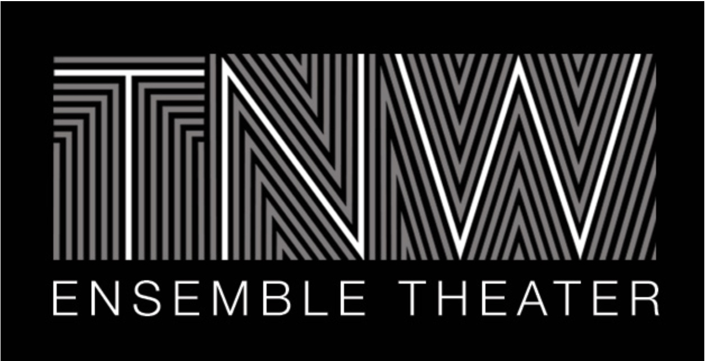

1957 Winnebago Street
Madison, WI 53704
www.tnwensembletheater.org
info@tnwensembletheater.org
608.244.2938

