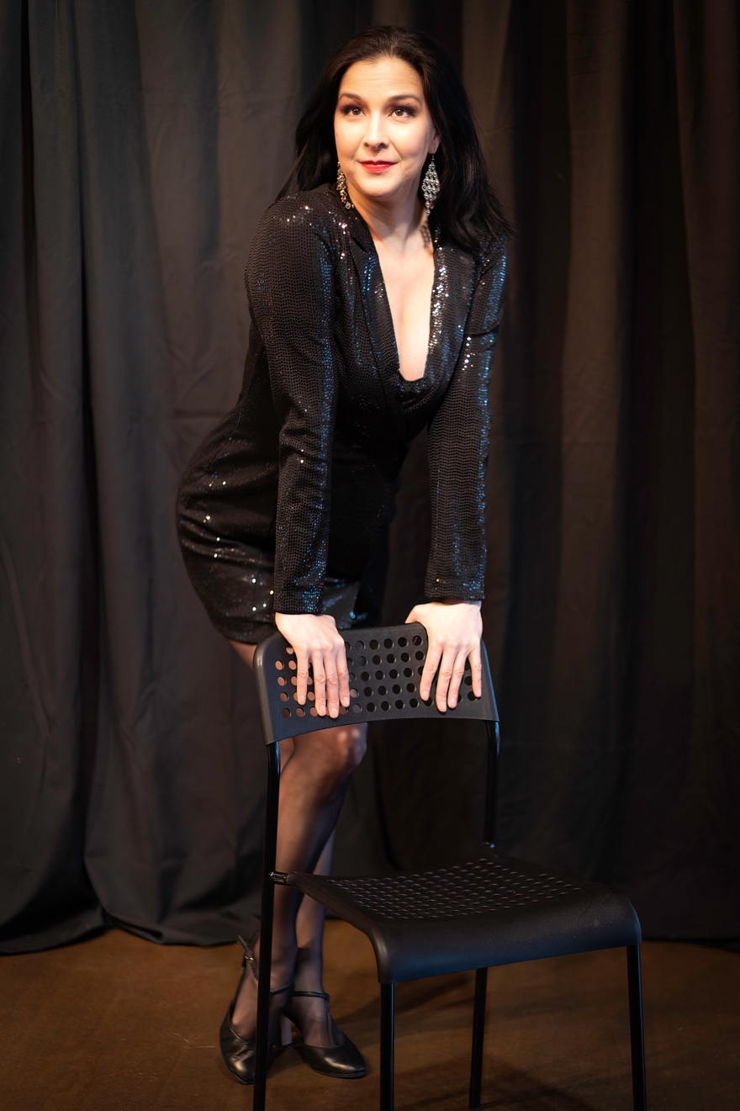
Kiki Moritsugu Bio

Kiki Moritsugu is a dancer, actor, singer, and performer from Toronto. She studied in Canada, performed extensively in NYC, is a musical theater artist, and trained in Japanese martial arts. Kiki Moritsugu appears through arrangement with Actors Equity Association. She is also a member of SAG.

Her career has encompassed theatre, television, film, and music videos, as well as industrial shows, both in Canada and in the United States. She has performed on Broadway (Shogun-The Musical), Off-Broadway (Tokyo Can Can), Off-Off Broadway (Touch), in Toronto (Cats at Massey Hall & 2nd National Tour) and in regional theatres across North America such as the Centaur Theatre (Montreal), The Guthrie Theatre (Minneapolis), Arena Stage, Kennedy Center, National Theatre (Washington, DC), Theatre Under the Stars (Houston & Seattle), and the Huntington Theatre (Boston). Film/TV credits include Delight in the Mountain (Frozen Stage Films), Chicago PD (NBC), The Ethical Slut (Independent), Sing (Tristar).

Recent theatre credits include Sally Bowles in Cabaret (Stage Q/ OUT!Cast Theatre), Wit and Wisdom (TNW Ensemble Theater), Legally Blonde, and Crazy for You (Middleton Players Theatre); Rock of Ages (MTG/OUT!Cast); Falsettos (Stage Q); 42nd St (MPT); Rocky Horror Show (OUT!Cast/Mercury); and Avenue Q (Middleton Players Theatre).

